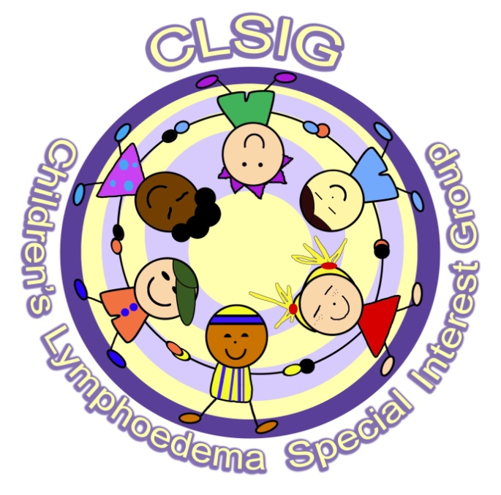 LYMPHALETICS 2018 APPLICATION FORM
Names of Parents/Guardians attending:
Address:
Tel No:
Email Address:
Name of child with lymphoedema
Age:
Size of T-shirt:
Choice of event: Swimming/Other (to be confirmed) (please delete as appropriate)
Name of sibling attending:
Age:
Size of T-shirt:
Choice of event: Swimming/Other (please delete as appropriate)
Name of sibling attending:
Age:
Size of T-shirt:
Choice of event: Swimming/Other (please delete as appropriate)
Name of sibling attending:
Age:
Size of T-shirt:
Choice of event: Swimming/Other (please delete as appropriate)
Do you have any dietary requirements/allergies? Yes/No. If yes please provide details

Do you consent to photographs being taken at the event and used for future publicity? Yes/No
Do you consent to sharing your email address with the other families attending the event? Yes/No
Return to: Gillian Craig, 11 Arbeadie Terrace, Banchory, AB31 5TN – or email gilliancraig@nhs.net

